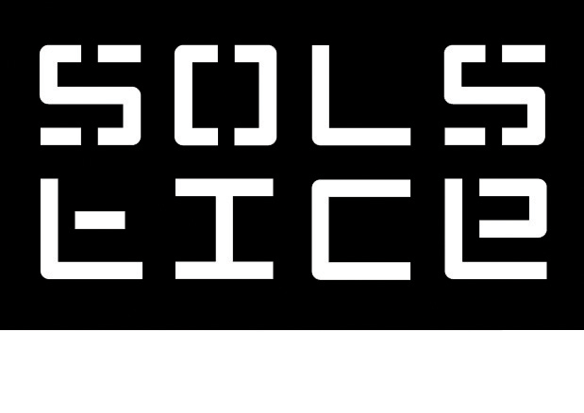

VISUAL ARTS CURATOR: Further information
We are seeking a dynamic visual arts curator who creates inspiring VA programmes that support and promote the work of artists, build visual arts audiences and work to a constant refining quality with our wider team.

€46,000 p.a. Full time 35 hrs p.w.

Responsible to: Director & General Manager
Responsible for: Visual Arts Learning & Participation Co-ordinator

About Solstice Arts Centre & Swift Cultural Centre
Entering its 20th year Solstice Arts Centre is a vibrant arts centre welcoming 150,000 visitors in 2024 and employing 35 staff. It programmes a range of local, national and international activities throughout its multidisciplinary arts programme, encouraging participation and engagement with our diverse range of activities. Facilities include theatre, three interconnecting visual arts galleries, 320 seated theatre with cinema facilities, café and visual arts foyer wall. It is proud of its continuing support of artists through its wide ranging production resources and project commissioning practice. In 2023, Solstice was appointed to operate the newly built Swift Cultural Centre in Trim by Meath County Council. These facilities include a 235 seater theatre, cinema (February 2026), a multi-use church space and meeting rooms.


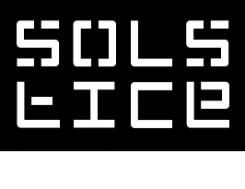

Current Visual Arts Programme
- Solstice Arts Centre currently produces 5 exhibition per annum. 4 of which are a mixture of much lauded group and solo exhibitions by contemporary Irish and international artists. Solstice also produces an annual local open call exhibition, Surveyor, which is selected by an invited independent curator.

- We produce ambitious artwork with artists that can involve off site installation, commissioning and international/national touring.

- We produce a year-round ecological socially engaged programme “Take Me to the River” involving dialogue and activities between scientists, artists, landowners and the public.

- A vibrant and essential learning and engagement programme is curated in tandem with each exhibition across disciplines and with diverse participants in mind.

- Due to the diverse range of use Swift Cultural Centre Church Space, we currently have begun two exploratory local VA exhibition open calls. In 2026 we will begin a “Test lab” programme to provide space and support for concentrated artistic research and development. The incoming Visual Arts Curator is asked to further develop the VA programme within Swift.

About the Role
We are seeking a visual arts curator who creates inspiring VA programmes that support and promote the work of artists, build visual arts audiences and work with the wider team to increase the profile of our visual arts programme locally, nationally and internationally to an ever refining quality.

The Visual Arts Curator must have the ability and consideration to programme ambitiously at a national and international level (where feasible) whilst generously supporting local professional visual arts practice.

The Visual Arts Curator is fully responsible for the organisation and production of all visual arts activities at our centre and must be able to multi-task, have excellent organisational, budgetary, and writing skills.

The Visual Arts Curator will co-ordinate the visual arts programme with the Director, to maximise the potential of the programme, whilst ensuring the strategic and artistic objectives of our organisation are met. The Director welcomes new perspectives in all aspects of visual arts practice at Solstice.

Solstice/Swift is built on the mutual respect, communication and collegiality of all staff at our centres, upholding a busy but supportive workplace ethos. The incoming Visual Arts Curator is expected to integrate fully within our dedicated team, and at all times listen and communicate with artists, visitors and staff with dignity, respect and empathy.

Duties
- Responsible for the planning, creation and successful implementation of all aspects of our visual artist programme at Solstice Arts Centre and Swift Cultural Centre
- Liaise with artists (and galleries) regarding their work, its installation requirements, and expectations for the work in exhibition.
- To manage and fulfill logistical and technical requirements of our VA activities
- Nurture and develop positive working relations with artists, visual arts institutions and curators
- Co-ordinate the delivery of any accompany artist publications
- Provide public mediation texts as well as any required critical writing for Solstice publications
- Support and positively advocate for Solstice/Swift Visual Arts programme as a senior team member.
- Communicate with the wider Solstice team on all artistic, promotional, technical operations.
- Work in tandem with Solstice/Swift Marketing Manager in the media promotion of the Visual Arts programme.
- To update and monitor visual arts database in collaboration with the Marketing Manager complying to GDPR regulations
- Assist with artist hospitality arrangements, ensuring artists and contributors are welcomed and comfortable whilst working with Solstice/Swift.
- Contribute to overall evaluation of exhibitions, and future build new VA initiatives and artistic policy.
- Manage and record exhibitions and programming budget.
- Identify potential additional funding sources where relevant.
- Contribute to visual art programming information in grant applications.
- Prepare budgetary, audience and programme reports for stakeholders and Board of Directors



General Team Duties
- To comply with in house policies, systems and procedures at all times
- Participate in regular team meetings
- To undergo any appropriate training as directed by the Director.
- To carry out any other tasks that will from time to time be allocated by the Director on an ad hoc or continuing basis commensurate with the general level of responsibility of the post

Key Requirements
- 3 years curatorial experience working within, or with a visual arts institution.
- Demonstrated visual arts curation of exceptional quality.
- Excellent administrative skills including demonstrated budget management.
- Ability to manage others as well as self-motivate effectively
- Up to date knowledge of Irish and international contemporary arts practice, trends and concerns.

Important information
- Closing date for Applications: Thursday 06 November, 5pm
- Applications should include cover letter and CV and be forwarded to alison.dowling@solsticeartscentre.ie
- Queries concerning the role should only be forwarded to alison.dowling@solsticeartscentre.ie
- No late applicants will be considered
- Shortlisted candidates will be asked to attend interview on 08 December.
- MAC DAC Ltd. is an equal opportunities employer ensuring the arts industry is fully representative of our diverse Irish society.




